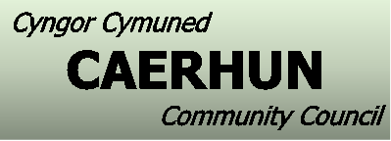

Cofnodion / Minutes – 29.04.24

Cadeirydd/Chairman |  |  | Dewi Vaughan Jones
Presennol/Present |  |  | Jimmy Logan  Gareth Hughes  Eryl Roberts  Rhun Edwards | William Hugh Roberts  Dewi Jones  Siân Wyn Jones (Clerc)
Ymddiheuriadau/Apologies |  |  | Terry Evans  Cledwyn Griffiths  Colin Jones | Geraint Davies  Cyng. Goronwy Edwards

- COFNODION
Darllenwyd y cofnodion a chytunwyd eu bod yn gywir.

- DATGANIAD O DDIDDORDEB
Dim i’w gofnodi.

- MATERION YN CODI
- Toiledau Rowen
Hysbysodd y clerc bod CBSC dal heb wneud penderfyniad ynglŷn â dyfodol toiledau Rowen.

- UNRHYW FATER ARALL
- Car ger Farchwel
Gofynnodd Rhun Edwards os oedd CBSC wedi gyrru ymateb ynglŷn â’r car oedd wedi parcio ger Farchwel, hysbysodd y clerc ei bod nhw wedi gyrru’r manylion ymlaen i’r DVLA I ddelio gyda’r mater.

Caewyd y cyfarfod am 7.40yh, cynhelir y cyfarfod nesaf Nos Lun 3ydd o Fehefin 2024 7.30yh

- MINUTES
The minutes from the previous meeting were agreed as an accurate record.

- DECLARATION OF INTERESTS
None declared.

- MATTERS ARISING
- Rowen Toilets
The clerk advised CCBC still hadn’t made a final decision in relation to the future of the toilets.

- ANY OTHER BUSINESS
- Parked Car by Farchwel
Rhun Edwards asked if CCBC had responded to the abandoned car by Farchwel, the clerk advised they had passed the details onto DVLA to deal with the matter.

The meeting closed at 7.40pm, the next meeting is scheduled Monday 3rd June 2024 7.30pm

